Nama : Firly Nurlya R
NIM : 4510210032
Praktikum sesi 6 - Pemrograman 4

Produk.java
package com.training.springmvc;

import java.math.BigDecimal;
import java.util.Date;
import javax.validation.constraints.Min;
import javax.validation.constraints.NotNull;
import javax.validation.constraints.Size;
import org.hibernate.validator.constraints.NotEmpty;

public class Produk {
private Integer id;

@NotNull
@NotEmpty
@Size(min= 1, max = 5)
private String kode;

@NotNull @NotEmpty
@Size(min = 5, max = 255)
private String nama;

@Min(100)
private BigDecimal harga;

private Date terakhirUpdate;

public Integer getId() {
return id;
}

public void setId(Integer id) {
this.id = id;
}

public String getKode() {
return kode;
}

public void setKode(String kode) {
this.kode = kode;
}

public String getNama() {
return nama;
}

public void setNama(String nama) {
this.nama = nama;
}

public BigDecimal getHarga() {
return harga;
}

public void setHarga(BigDecimal harga) {
this.harga = harga;
}

public Date getTerakhirUpdate() {
return terakhirUpdate;
}

public void setTerakhirUpdate(Date terakhirUpdate) {
this.terakhirUpdate = terakhirUpdate;
}
}

ProdukDao.java
package com.training.springmvc;

import java.sql.Connection;
import java.sql.PreparedStatement;
import java.sql.ResultSet;
import java.sql.SQLException;
import java.util.ArrayList;
import java.util.List;
import javax.sql.DataSource;
import org.springframework.beans.factory.annotation.Autowired;
import org.springframework.stereotype.Repository;

@Repository
public class ProdukDao {

@Autowired private DataSource dataSource;

private String sqlInsert = "insert into produk (kode, nama, harga, terakhir_update) " + "values (?,?,?,?)";
private String sqlUpdate = "update produk set kode=?, nama=?, harga=?, terakhir_update=? " + "where id = ?";
private String sqlCariSemuaProduk = "select * from produk order by kode";
private String sqlCariById = "select * from produk where id = ?";
private String sqlHapusById = "delete from produk where id = ?";

public void simpan(Produk p) throws Exception {
Connection c = dataSource.getConnection();

if (p.getId() == null) {
PreparedStatement psInsert = c.prepareStatement(sqlInsert);
psInsert.setString(1, p.getKode());
psInsert.setString(2, p.getNama());
psInsert.setBigDecimal(3, p.getHarga());
psInsert.setDate(4, new java.sql.Date(p.getTerakhirUpdate().getTime()));

psInsert.executeUpdate();
} else {
PreparedStatement psUpdate = c.prepareStatement(sqlUpdate);
psUpdate.setString(1, p.getKode());
psUpdate.setString(2, p.getNama());
psUpdate.setBigDecimal(3, p.getHarga());
psUpdate.setDate(4, new java.sql.Date(p.getTerakhirUpdate().getTime()));
psUpdate.setInt(5, p.getId());

psUpdate.executeUpdate();
}
c.close();
}

public List<Produk> cariSemuaProduk() throws Exception {
List<Produk> hasil = new ArrayList<Produk>();

Connection c = dataSource.getConnection();
PreparedStatement psCariSemuaProduk = c.prepareStatement(sqlCariSemuaProduk);

ResultSet rs = psCariSemuaProduk.executeQuery();
while(rs.next()){
Produk p = konversiResultSetKeProduk(rs);
hasil.add(p);
}

c.close();
return hasil;
}

public Produk cariById(Integer id) throws Exception{
if(id == null){
return null;
}
Connection c = dataSource.getConnection();
PreparedStatement psCariById = c.prepareStatement(sqlCariById);
psCariById.setInt(1, id);
ResultSet rs = psCariById.executeQuery();
if(!rs.next()){
return null;
}
Produk p = konversiResultSetKeProduk(rs);
c.close();
return p;
}

public Produk konversiResultSetKeProduk(ResultSet rs) throws SQLException{
Produk p = new Produk();
p.setId(rs.getInt("id"));
p.setKode(rs.getString("kode"));
p.setNama(rs.getString("nama"));
p.setHarga(rs.getBigDecimal("harga"));
p.setTerakhirUpdate(rs.getDate("terakhir_update"));
return p;
}

public void hapus(Integer id) throws Exception{
if(id == null){
return;
}
Connection c = dataSource.getConnection();
PreparedStatement psHapusById = c.prepareStatement(sqlHapusById);
psHapusById.setInt(1, id);
psHapusById.executeUpdate();
c.close();
}
}

ProdukController.java
package com.training.springmvc;

import java.math.BigDecimal;
import java.util.Date;
import java.util.List;
import javax.validation.Valid;
import org.springframework.beans.factory.annotation.Autowired;
import org.springframework.stereotype.Controller;
import org.springframework.ui.ModelMap;
import org.springframework.validation.BindingResult;
import org.springframework.web.bind.annotation.ModelAttribute;
import org.springframework.web.bind.annotation.RequestMapping;
import org.springframework.web.bind.annotation.RequestMethod;
import org.springframework.web.bind.annotation.RequestParam;
import org.springframework.web.bind.support.SessionStatus;

@Controller
public class ProdukController {

@Autowired private ProdukDao produkDao;

@RequestMapping("/produk/daftar-produk")
public ModelMap daftarProduk() throws Exception{
List<Produk> hasil = produkDao.cariSemuaProduk();
ModelMap mm = new ModelMap();
mm.addAttribute("daftarProduk", hasil);
return mm;
//System.out.print("daftar Produk");
}

@RequestMapping(value = "/produk/input-produk", method = RequestMethod.GET)
public ModelMap tampilkanFormProduk(@RequestParam(required = false) Integer id) throws Exception {
System.out.print("menampilkan form Produk");

Produk p = produkDao.cariById(id);

if(p == null){
p = new Produk();
}

ModelMap mm = new ModelMap();
mm.addAttribute("produk", p);
return mm;
}

@RequestMapping(value = "/produk/input-produk", method = RequestMethod.POST)
public String prosesProduk(@ModelAttribute @Valid Produk p, BindingResult hasilValidasi, SessionStatus status) throws Exception{
p.setTerakhirUpdate(new Date());

if(hasilValidasi.hasErrors()){
return "/produk/input-produk";
}

produkDao.simpan(p);
status.setComplete();
return "redirect:daftar-produk";
}

@RequestMapping("/produk/hapus")
public String hapusProduk(@RequestParam Integer id) {
try {
produkDao.hapus(id);
} catch (Exception err){
System.out.println("Gagal hapus : "+err.getMessage());
}
return "redirect:daftar-produk";
}
}

Daftar-produk.jsp
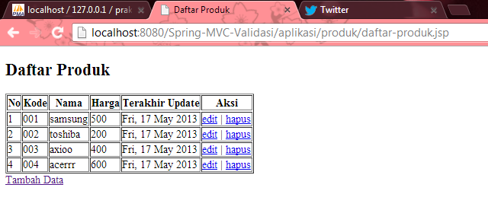

Jika ingin menambahkan data:
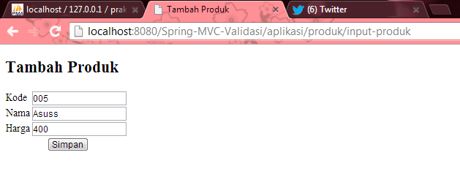
Maka data bertambah, kode 005.
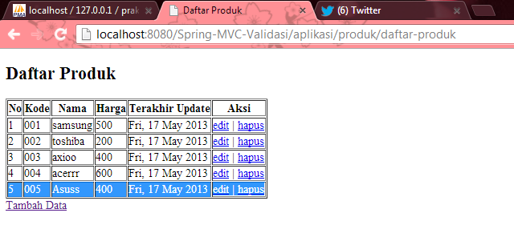
Aksi Hapus:
Kode 004 telah terhapus
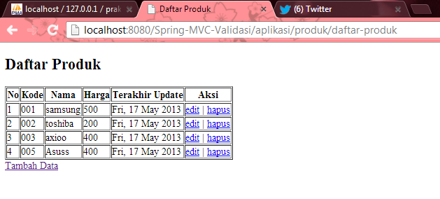

Aksi Edit:
Mengedit data yang kode nya 001 menjadi 006
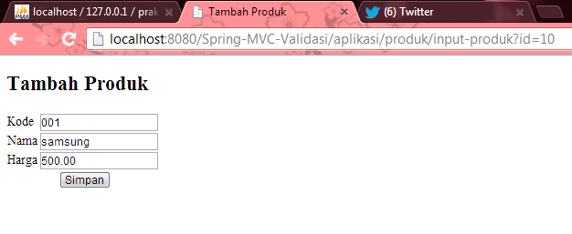
Hasilnya:
Kode 001 telah terubah menjadi 006.
